***Solution*** ***Section* 1.7 – Physical Applications**

***Exercise***

Find the mass of a thin bar with the given density function 

***Solution***

 







***Exercise***

Find the mass of a thin bar with the given density function 

***Solution***

 







***Exercise***

Find the mass of a thin bar with the given density function 

***Solution***

 







***Exercise***

Find the mass of a thin bar with the given density function 

***Solution***

 







***Exercise***

Find the mass of a thin bar with the given density function 

***Solution***

 









***Exercise***

Find the mass of a thin bar with the given density function 

***Solution***

 







***Exercise***

Find the mass of a thin bar with the given density function 

***Solution***

 







***Exercise***

Find the mass of a thin bar with the given density function 

***Solution***

 







***Exercise***

Find the mass of a bar on the interval  with a density (in *g/cm*) given by 

***Solution***

 







***Exercise***

Find the mass of a 3-*m* bar on the interval  with a density (in *g/m*) given by 

***Solution***

 







***Exercise***

Find the mass of a bar on the interval  with a density 

***Solution***

 







***Exercise***

It takes 50 *J* of work to stretch a spring 0.2 *m* from its equilibrium position. How much work is needed to stretch it an additional 0.5 *m*?

***Solution***



















***Exercise***

It takes 50 *N* of force to stretch a spring 0.2 *m* from its equilibrium position. How much work is needed to stretch it an additional 0.5 *m*?

***Solution***















***Exercise***

A cylindrical water tank has a height of 6 *m* and a radius of 4 *m*. how much work is required to empty the full tank by pumping the water to an outflow pipe at the top of the tank?

***Solution***











***Exercise***

Find the total force on the face of a semicircular dam with a radius of 20 *m* when its reservoir is full of water. The diameter of the semicircle is the top of the dam.

***Solution***























***Exercise***

A rock climber is about to haul up 100 *N* (about 22.5 *lb.*) of equipment that has been hanging beneath her on 40 *m* rope that weighs 0.8 *N/m*. How much work will it take? (*Hint*: Solve for the rope and equipment separately, then add)

***Solution***

Equipment alone: 







Rope: 













***Exercise***

A 2-oz tennis ball was served at . How much work was done on the ball to make it go this fast?

(to find the ball’s mass from its weight, express the weight in pounds and divide by , the acceleration of gravity.)

***Solution***













***Exercise***

How many foot-pounds of work does it take to throw a baseball 90 *mph*? A baseball weights 5 *oz*.

***Solution***

















***Exercise***

A 1.6-*oz* golf ball is driven off the tee at a speed of . How many foot-pounds of work are done on the ball getting it into the air?

***Solution***













***Exercise***

You drove an 800-*gal* tank truck of water from the base of a mountain to the summit and discovered on arrival that the tank was only half full. You started with a full tank, climbed at a steady rate, and accomplished the 4750-*ft* elevation change in 50 *min*. Assuming that the water leaked out at a steady rate, how much work was spent in carrying water to the top? Do not count the work done in getting yourself and the truck there. Water weighs 8 *lb/gal*.

***Solution***



















***Exercise***

A force of 200 *N* will stretch a garage door spring 0.8 *m* beyond its unstressed strength. How far will a 300-*N* force stretch the spring? How much work does it take to stretch the spring this far from its unstressed length?

***Solution***















***Exercise***

A heavy-duty shock absorber is compressed 2 *cm* from its equilibrium position by a mass of 500 *kg*. How much work is required tocompress the shock absorber 4 *cm* from its equilibrium position? (A mass of 500 *kg* exerts a force (in newtons) of 500 *g*)

***Solution***

***Given***: 

 





 





***Exercise***

A spring has a restoring force given by . Let  be the work required to stretch the spring from its equilibrium position  to a variable distance *x*. Graph the work function. Compare the work required to stretch the spring *x* units from equilibrium to the work required to compress the spring *x* units from equilibrium.

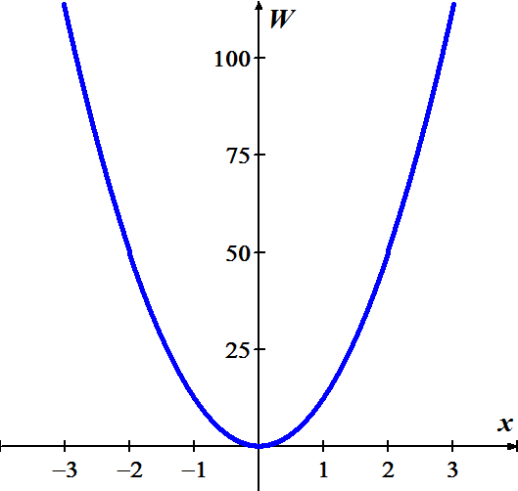***Solution***

 





Since  is an even function.

So that , and thus the work is the same to compress or stretch the spring a given distance from its equilibrium position.

***Exercise***

A swimming pool has the shape of a box with a base that measures 25 *m* by 15 *m* and a depth of 2.5 *m*. How much work is required to pump the water out of the pool when it is full?

***Solution***











***Exercise***

Find the fluid force on a rectangular metal sheet measuring 3 *feet* by 4 *feet* that is submerged in 6 *feet* of water.

***Solution***

Freshwater Weight density: 





***Exercise***

It took 1800 *J* of work to stretch a spring from its natural length of 2 *m* to a length of 5 *m*. Find the spring’s force constant

***Solution***















***Exercise***

How much work is required to move am object from  to  (measired in meters) in the presence of a constant force at 5 *N* acting along the .

***Solution***







***Exercise***

How much work is required to move am object from  to  (measired in meters) with a force (in *N*) is given by  acting along the .

***Solution***









***Exercise***

A spring on a horizontal surface can be stretched and held 0.5 *m* from its equilibrium position with a force of 50 *N*.

1. How much work is done in stretching the spring 1.5 *m* from its equilibrium position?
2. How much work is done in compressing the spring 0.5 *m* from its equilibrium position?

***Solution***

1. 











1. 





***Exercise***

Suppose a force of 10 *N* is required to stretch a spring 0.1 *m* from its equilibrium position and hold it in that position.

1. Assuming that the spring obeys Hooke’s law, find the spring constant *k*.
2. How much work is needed to ***compress*** the spring 0.5 *m* from its equilibrium position?
3. How much work is needed to ***stretch*** the spring 0.25 *m* from its equilibrium position?
4. How much additional work is required to stretch the spring 0.25 *m* if it has already been stretched 0.1 *m* from its equilibrium position?

***Solution***

1. 





Therfore, Hooke’s law for this spring: 

1. Work is needed to ***compress*** the spring









1. Work is needed to ***stretch*** the spring









1. Work is required to ***stretch*** the spring









***Exercise***

A force of 200 N will stretch a garage door spring 0.8-*m* beyond its unstressed length.

1. How far will a 300-N-force stretch the spring?
2. How much work does it take to stretch the spring this far?

***Solution***





1. 



1. 





***Exercise***

A spring has a natural length of 10 *in*. An 800-*lb* force stretches the spring to 14 *in*.

1. Find the force constant.
2. How much work is done in stretching the spring from 10 *in* to 12 *in*?
3. How far beyond its natural length will a 1600-*lb* force stretch the spring?

***Solution***

1. 







1. 













1. 







***Exercise***

It takes a force of 21,714 *lb* to compress a coil spring assembly on a Transit Authority subway car from its free height of 8 *in*. to its fully compressed height of 5 *in*.

1. What is the assembly’s force constant?
2. How much work does it take to compress the assembly the first half inch? The second half inch? Answer to the nearest *in-lb*.

***Solution***

1. 







1. 















***Exercise***

A mountain climber is about to haul up a 50 *m* length of hanging rope. How much work will it take if the rope weighs 0.624 *N/m*?

***Solution***









***Exercise***

A bag of sand originally weighing 144 *lb* was lifted a constant rate. As it rose, sand also leaked out at a constant rate. The sand was half gone by the time the bag had been lifted to 18 *ft*. How much work was done lifting the sand this far? (Neglect the weight of the bag and lifting equipment.)

***Solution***

The weight of sands decreases by  over the 18 ft. at rate 











***Exercise***

An electric elevator with a motor at the top has a multistrand cable weighing 4.5 *lb/ft*. When the car is at the first floor, 180 *feet* of cable are paid out, and effectively 0 *foot* are out when the car is at the top floor. How much work does the motor do just lifting the cable when it takes the car from the first floor to the top?

***Solution***











***Exercise***

The rectangular cistern (storage tank for rainwater) shown has its top 10 *ft* below ground level. The cistern, currently full, is to be emptied for inspection by pumping its contents to ground level. Assume that the water weighs 

1. How much work will it take to empty the cistern?
2. How long will it take a 1*/-hp* pump, rated at 275 *ft-lb/sec*, to pump the tank dry?
3. How long will it take the pump in part (*b*) to empty the tank hallway? ( It will be less than half the time required to empty the tank completely)
4. What are the answers to parts (*a*) through (*c*) in a location where water weighs 62.6 ? 62.59 ?

***Solution***

1. 







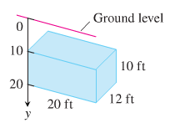











1. 







1. 















1. ***Water weighs*** 

























***Water weighs*** 

























***Exercise***

When a particle of mass *m* is at (*x*, 0), it is attracted toward the origin with a force whose magnitude is . If the particle starts from rest at *x* = *b* and is acted on by no other forces, find the work done on it by the time reaches *x* = *a*, 0 < *a* < *b*.

***Solution***





 







***Exercise***

The strength of Earth’s gravitation field varies with the distance *r* from Earth’s center, and the magnitude of the gravitational force experienced by a satellite of mass *m* during and after launch is



Here,  is Earth’s mass,  is the universal gravitational constant, and *r* is measured in meters. The work it takes to lift a 1000-*kg* satellite from Earth’s surface to a circular orbit 35,780 *km* above Earth’s center is therefore given by the integral



Evaluate the integral. The lower limit of integration is Earth’s radius in meters at the launch site. (This calculation does not take into account energy spend lifting the launch vehicle or energy spent bringing the satellite to orbit velocity.)

***Solution***









***Exercise***

You drove an 800-*gal* truck from the base of Mt. Washington to the summit and discovered on arrival that the tank was only half full. You started with a full tank, climbed at a steady rate, and accomplished the 4750*-ft* elevation change in 50 *minutes*.

Assuming that the water leaked out at a steady rate, how much work was spent in carrying the water to the top? Do not count the work done in getting yourself and the truck there. Water weighs 8- *lb*./*gal*.

***Solution***

The force required to lift the water is equal to the water's weight which varies *lbs*. to  *lbs*. over the 4750 *ft* change in elevation. Since it looses half of the water when the truck reaches its destination, it would loose all of the water if it went twice the distance. When the truck is *x* feet of the base of Mt. Washington, the water's weight is the following proportion.











***Exercise***

A cylindrical water tank has height 8 *m* and radius 2 *m*

1. If the tank is full of water, how much work is required to pump the water to the level of the top of the tank and out of the tank?
2. Is it true it takes half as much work to pump the water out of the tank when it is half full as when it is full? Explain.

***Solution***

1. 

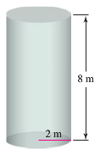 









1. The work done pumping the water from a half-full tank









To empty a half-full tank, the work is







NO, it is not true.

***Exercise***

A water tank is shaped like an inverted cone with height 6 *m* and base radius 1.5 *m*.

1. If the tank is full of water, how much work is required to pump the water to the level of the top of the tank and out of the tank?
2. Is it true it takes half as much work to pump the water out of the tank when it is half full as when it is full? Explain.

***Solution***







1. 











1. 







The work done is less than half the half amount from part (*a*).

It is not true, while the water must be raised further than water in the top half, due to the shape of the tank, there is far less water in the bottom half than in the top.

***Exercise***

A spherical water tank with an inner radius of 8 *m* has its lowest point 2 *m* above the ground. It is filled by a pipe that feed the tank at its lowest point.

1. Neglecting the volume of the inflow pipe, how much work is required to fill the tank if it is initially empty?
2. Now assume that the inflow pipe feeds the tank at the top of the tank. Neglecting the volume of the inflow pipe, how much work is required to fill the tank if it is initially empty?

***Solution***

1. Equation of the tank:

















1. The toal weight of the water lifted up for 18 *m* is









***Exercise***

A large vertical dam in the shape of a symmetric trapezoid has a height of 30 *m*. a width of 20 *m*. at its base, and a width of 40 *m*. at the top. What is the total force on the face of the dam when the reservoir is full? 

***Solution***







*Width*: 



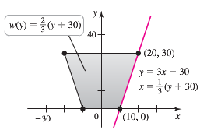*Depth*: 

*Boundary*: 













***Exercise***

A vertical gate in a dam has the shape of an isosceles trapezoid 8 *feet* across the top and 6 *feet* across the bottom. With a height of 5 *feet*. What is the fluid force on the gate if the top of the gate is 4 *feet* below the surface of the water?

***Solution***

Freshwater Weight density: 

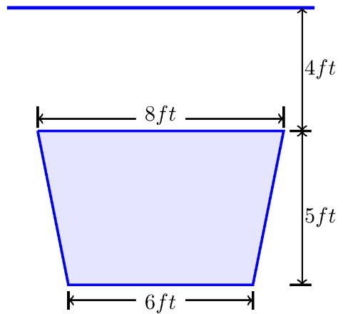







*Width*: 



*Depth*: 

*Boundary*: 

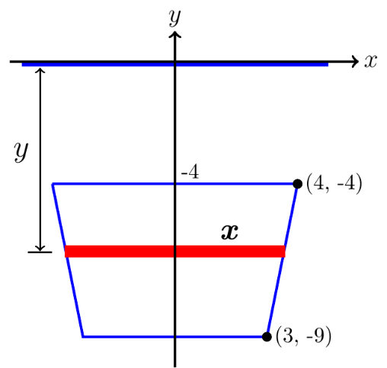













***Exercise***

Pumping water from a lake 15-*feet* below the bottom of the tank can fill the cylindrical tank shown here.

There are two ways to go about it. One is to pump the water through a hose attached to a valve in the bottom of the tank. The other is to attach the hose to the rim of the tank and let the water pour in. Which way will be faster? Give reason for answer

***Solution***

The water is being pumped from a lake that is 15-*feet* below the tank. That is the distance it takes to get the water from the lake to the valve, but this is not the total distance that the water is moved. We are forcing the water up into the tank, so the water travels a distance of *y* in the tank.

The total distance the water travels is 15 + *y*.

The cross-section is a circle: 









Now we are pumping the water to the top of the tank and letting it pour in.

Therefore, the distance that the water is pumped is 







***Exercise***

A tank truck hauls milk in a 6*-feet* diameter horizontal right circular cylindrical tank. How must force does the milk exert on each end of the tank when the tank is half full?

***Solution***

Diameter = 6 

Circular cylinder: 





Weight density of milk is 











***Exercise***

A triangular plate, base 5 *feet*, height 6 *feet*, is submerged in water, vertex down, plane vertical, and 2 *feet* below the surface. Find the total force on one face of the plate.

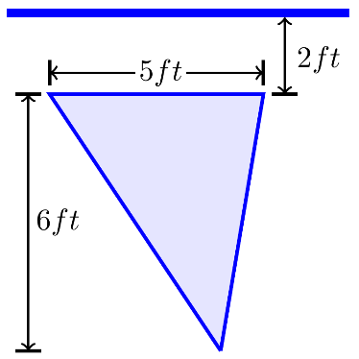***Solution***

Freshwater Weight density: 



*Width*: 

*Depth*: 

*Boundary*: 

 

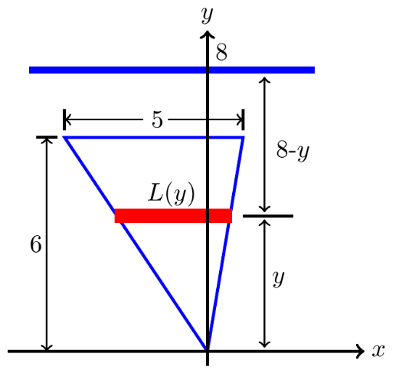 









***Exercise***

The vertical triangular plate shown here is the end plate of a trough full of water. What is the fluid force against the plate?

***Solution***

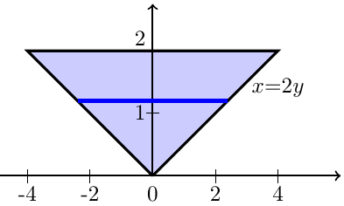











***Exercise***

A cylindrical gasoline tank is placed so that the axis of the cylinder is horizontal. Find the fluid force on a circular end of the tank if the tank is ***half full*** assuming that the diameter is 3 *feet* and the gasoline weighs 42 *pounds* per *cubic* *foot*.

***Solution***

Weight density: 

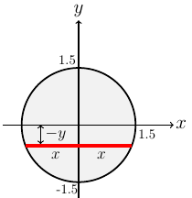





*Width*: 



*Depth*: 

*Boundary*: 









 

***Exercise***

A cylindrical gasoline tank is placed so that the axis of the cylinder is horizontal. Find the fluid force on a circular end of the tank if the tank is ***full*** assuming that the diameter is 3 *feet* and the gasoline weighs 42 *pounds* per *cubic* *foot*.

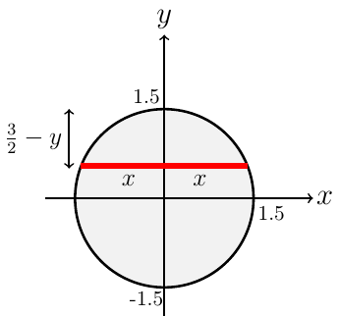***Solution***

Weight density: 







*Width*: 



*Depth*: 

*Boundary*: 



 









***Exercise***

A swimming pool is 20 *feet* wide, 40 *feet* long, 4 *feet* deep at one end, and 8 *feet* deep at the other end. The bottom is an inclined plane. Find the fluid force on each vertical wall.

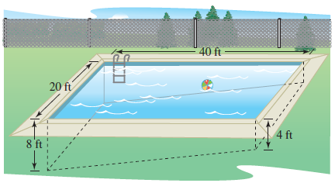

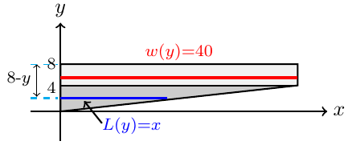***Solution***

*Depth*: 

***From*** 0−4 *ft*:





*Width*: 

*Boundary*: 

***From*** 4−8 *ft*:

*Width*: 

*Boundary*: 















***Exercise***

A swimming pool is 20 *m* leg long and 10 *m* wide, with a bottom that slopes uniformly from a depth of 1 *m* at one end to a depth of 2 *m* at the other end. Assuming the pool is full, how much work is required to pump the water to a level 0.2 *m* above the top of the pool?

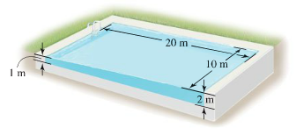***Solution***

Depth: 

***From*** 0−1 *m*:









***From*** 1−2 *m*:













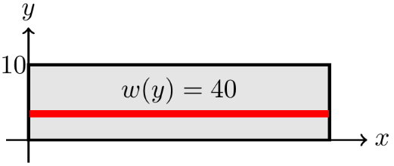***Exercise***

Find the total force on the face of the given dam

***Solution***

Freshwater Weight density: 









***Exercise***

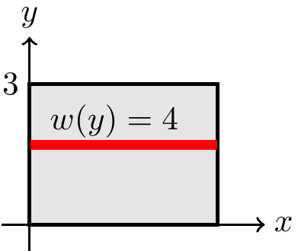Find the total force on the face of the given dam

***Solution***

Freshwater Weight density: 











***Exercise***

Find the total force on the face of the given dam

***Solution***

Freshwater Weight density: 









 









***Exercise***

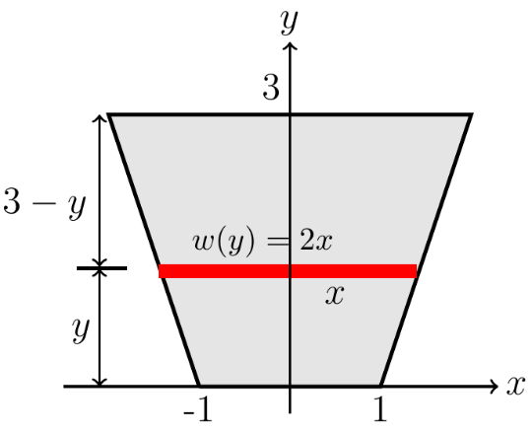Find the total force on the face of the given dam

***Solution***

Freshwater Weight density: 







*Width*: 



*Depth*: 

*Boundary*: 

 









***Exercise***

Find the total force on the face of the given dam

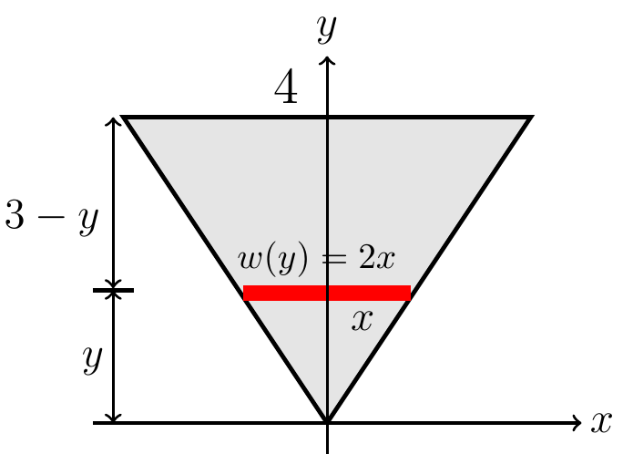***Solution***

Freshwater Weight density: 



*Width*: 



*Depth*: 

*Boundary*: 

 











***Exercise***

Find the total force on the face of the given dam 

***Solution***

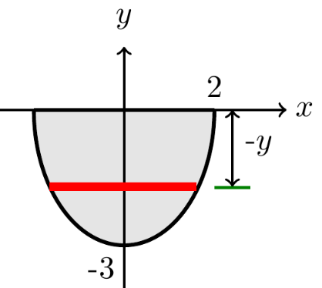Freshwater Weight density: 











*Width*: 



*Depth*: 

*Boundary*: 

 











***Exercise***

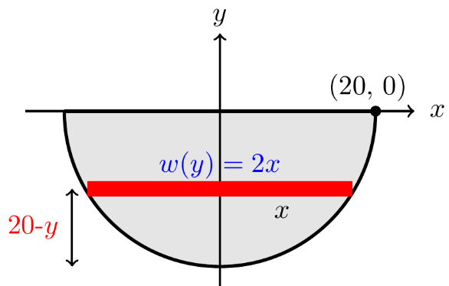Find the total force on the face of the given dam

***Solution***

Freshwater Weight density: 







 

.









***Exercise***

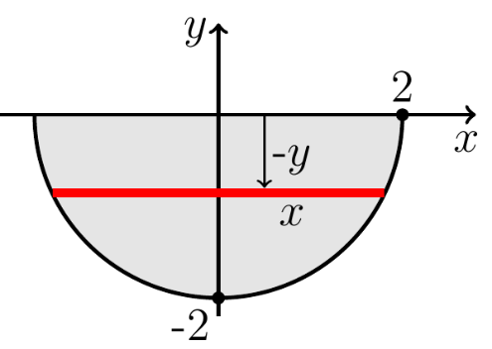Find the total force on the face of the given dam

***Solution***

Freshwater Weight density: 





*Width*: 



*Depth*: 

*Boundary*: 

 









***Exercise***

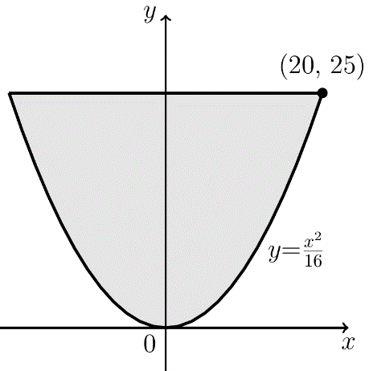Find the total force on the face of the given dam

***Solution***

Freshwater Weight density: 







*Depth*: 

*Boundary*: 

 











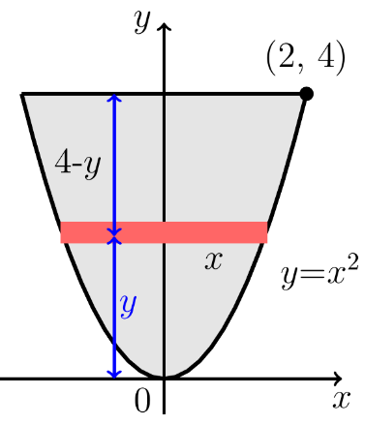***Exercise***

Find the total force on the face of the given dam:

***Solution***

Freshwater Weight density: 

*Width*: 

*Depth*: 

*Boundary*: 

 











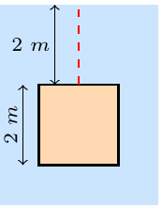***Exercise***

Find the fluid force on the vertical plate submerged in water

***Solution***

Freshwater Weight density: 

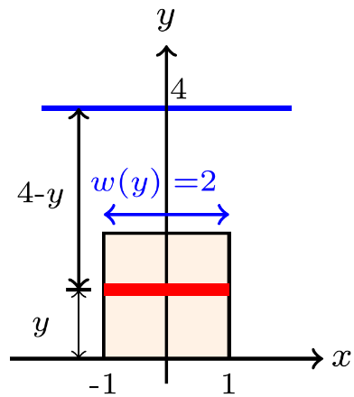*Width*: 

*Depth*: 

*Boundary*: 









***Exercise***

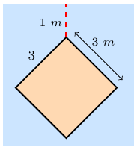Find the fluid force on the vertical plate submerged in water

***Solution***

Freshwater Weight density 









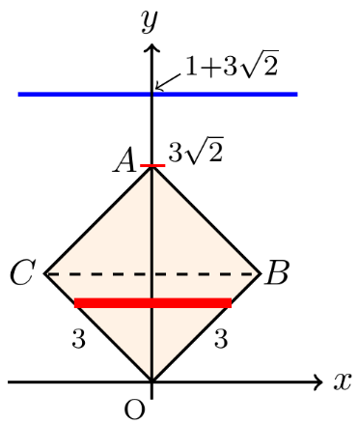*Depth*: 

The area below the dashed *BC* line:

Line *OB*: 

*Width*: 

*Boundary*: 

The area above the dashed *BC* line:



Line *AB*: 





*Width*: 



*Boundary*: 

















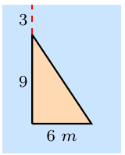***Exercise***

Find the fluid force on the vertical plate submerged in water

***Solution***

Freshwater Weight density: 





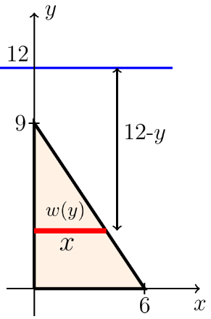

*Width*: 

*Depth*: 

*Boundary*: 















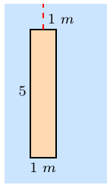***Exercise***

Find the fluid force on the vertical plate submerged in water

***Solution***

Freshwater Weight density: 

*Width*: 

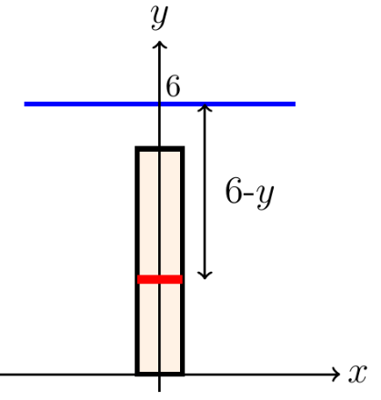*Depth*: 

*Boundary*: 











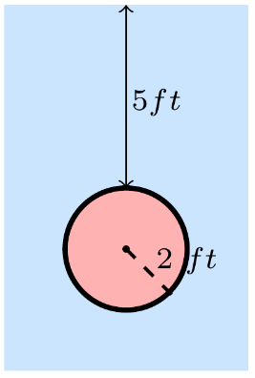***Exercise***

Find the fluid force on the vertical plate submerged in water

***Solution***

Freshwater Weight density: 



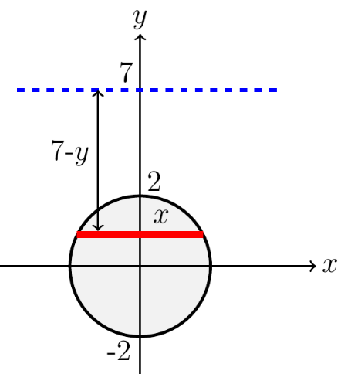

*Width*: 



*Depth*: 

*Boundary*: 



 









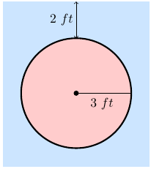***Exercise***

Find the fluid force on the vertical plate submerged in water

***Solution***

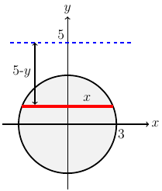Freshwater Weight density: 





*Width*: 



*Depth*: 

*Boundary*: 

 

 









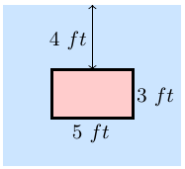***Exercise***

Find the fluid force on the vertical plate submerged in water

***Solution***

Freshwater Weight density: 

*Width*: 

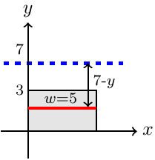*Depth*: 

*Boundary*: 

 









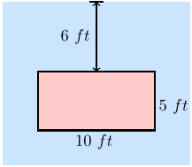***Exercise***

Find the fluid force on the vertical plate submerged in water

***Solution***

Freshwater Weight density: 

*Width*: 

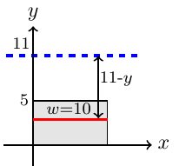*Depth*: 

*Boundary*: 











***Exercise***

A rectangular plate of height ***h*** *feet* and base ***b*** *feet* is submerged vertically in a tank of fluid that weighs ***w*** *pounds per cubic foot*. The center is ***k*** *feet* below the surface of the fluid, where . Show that the fluid force on the surface of the plate is 

***Solution***

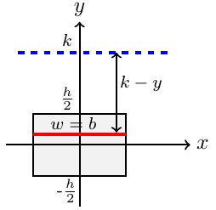Fluid Weight density: 

*Width*: 

*Depth*: 

*Boundary*: 









***Exercise***

A circular plate of radius ***r*** *feet* is submerged vertically in a tank of fluid that weighs ***w*** *pounds per cubic foot*. The center of the circle is  *feet* below the surface of the fluid. Show that the fluid force on the surface of the plate is .

***Solution***

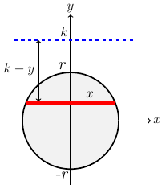Weight density: 





*Width*: 



*Depth*: 

*Boundary*: 



 









***Exercise***

A large building shaped like a box is 50 *m* high with a face that is 80 *m* wide. A strong wind blows directly at the face of the building, exerting a pressure of  at the ground and increasing with height according to , where *y* is the height above the ground. Calculate the total force on the building, which is a meaure of the resistance that must be included in the design of the building.

***Solution***

 







***Exercise***

Adiving pool that is 4 *m* deep full of water has a viewing window on one of its vertical walls. Find the force of the a square window, 0.5 *m* on side, with the lower edge of the window on the bottom of the pool.

***Solution***

Freshwater Weight density: 

 









***Exercise***

Adiving pool that is 4 *m* deep full of water has a viewing window on one of its vertical walls. Find the force of the a square window, 0.5 *m* on side, with the lower edge of the window 1 *m* from the bottom of the pool.

***Solution***

Freshwater Weight density: 

 











***Exercise***

Adiving pool that is 4 *m* deep full of water has a viewing window on one of its vertical walls. Find the force of the a circle window, with a radius of 0.5 *m*, tangent to the bottom of the pool.

***Solution***

Equation of the circle: 













 



 *Area of semicircle*: 









***Exercise***

A rigid body with a mass of 2 *kg* moves along a line due to a force that produces a position function , where *x* is measured in *meters* and *t* is measured in *seconds*. Find the work done during the first 5 *sec*. in two ways.

1. Note that ; then use Newton’s second law,  to evaluate the work integral , where  and  are the initial and final positions, repectively.
2. Change variables in the work integral and integrate with respect to *t*.

***Solution***

1. 

 





1. 









***Exercise***

A plate shaped like an equilateral triangle 1 *m* on a side is placed on a vetical wall 1 *m* below the surface of a pool filled with water. On which plate in the figure is the force is greater

***Solution***

The left picture has more force than the right, because of the bottom part is wider side in the pool.

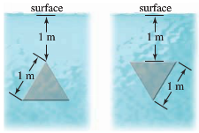For the left side plate:



Line segement: 



 









 



For the right side plate:

Line segement: 













***Exercise***

A square plate 1 *m* on a side is placed on a vetical wall 1 *m* below the surface of a pool filled with water.

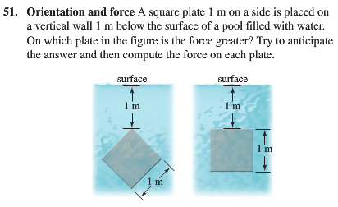

On which plate in the figure is the force is greater

***Solution***

For the plate on left side :



Line segment *OA*: 

Line segment *AB*:















  



For the plate on right side:









***Exercise***

Water fills a tank in the shape of a right-circular cone with top radius 3 *m* and depth 4 *m*. How much work must be done (against gravity) to pump all the water out of the tank over the top edge of the tank?

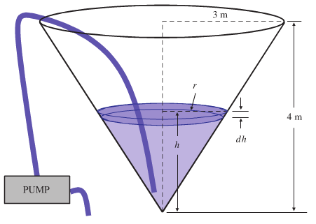

***Solution***

 (similar triangles)

The volume of this slice is:



And its weight (the force of gravity on the mass of water in the slice) is



The water in this disk must be raised (against gravity) a distance (4 – *h*) *m* by the pump. The work required to do this is















***Exercise***

You are in charge of the evacuation and repair of the storage tank.

The tank is a hemisphere of radius 10 *feet* and is full of benzene weighing 56 . A firm you contacted says it can empty the tank for *ȼ* per foot-pound of work. Find the work required to empty the tank by pumping the benzene to an outlet 2 *feet* above the top of the tank. If you have $5,000 budget for the job, can you afford to hire the firm?

***Solution***

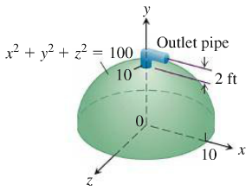







The force is:





The distance thorugh which  must act to lift the slab to the level of 2 *feet* above the top of the tank is about , so the work done is

.

And on the interval from  to 













 *ȼ*





***Exercise***

You decided to drill a well to increase a water supply.

You have determined that a water tower will be necessary to provide the pressure needed for distribution

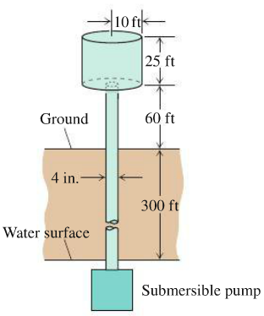

The water is to be pumped from a 300-*ft* well through a vertical 4-*in*. pipe into the base of a cylindrical tank 20 *feet* in diameter and 25 *feet* high. The base of the tank will be 60 *feet* above ground. The pump is a 3-*hp* pump, rated at . How long will it take to fill the tank the first time? (Include the time it takes to fill the pipe). Assume that water weighs 

***Solution***







The force is:





The distance thorugh which  must act to lift the slab is , so the work done is

.











To fill the pipe, the reuired work by taking the radius







The force is:







The distance thorugh which  must act to lift the slab is , so the work done is

.















To fill the tank the first time, it will take









***Exercise***

Calculate the fluid force on one side of a right-triangular plate with edges 3 *feet*, 4 *feet*, and 5 *feet* if the plate sits at the bottom of the pool filled with water to a depth of 6 *feet* on its 3-*feet* edge and titlted at  to the bottom of the pool.

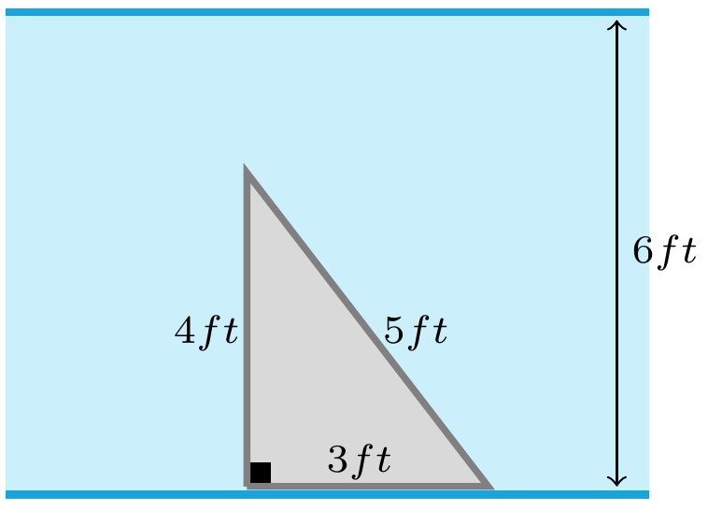 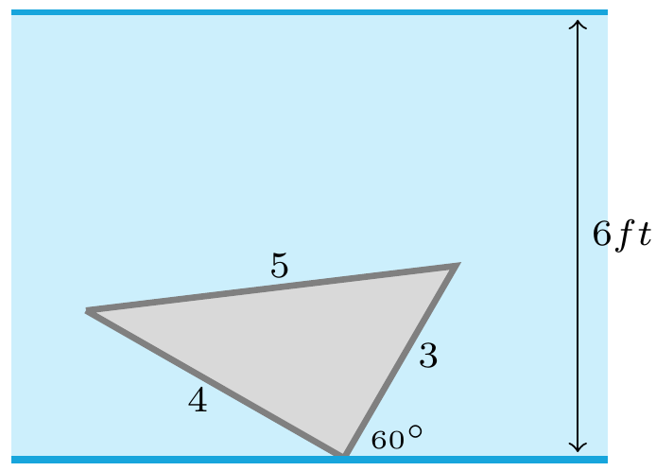

***Solution***

Freshwater Weight density: 

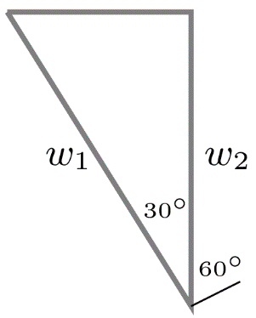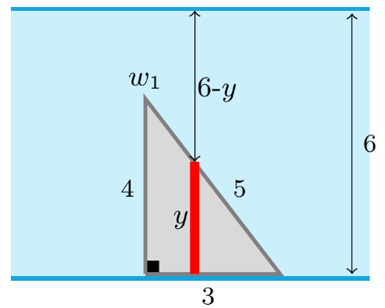







Boundary: 

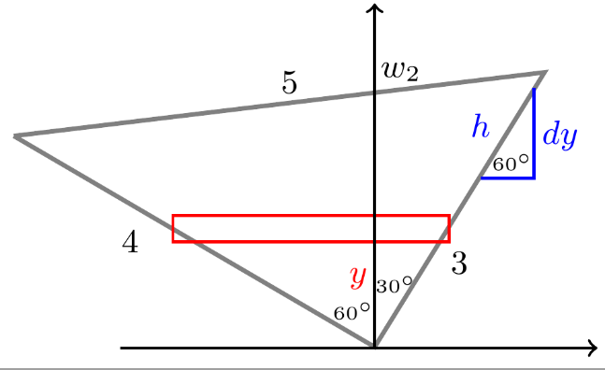Depth: 









Width: 

 













***Exercise***

Two electrons *r* *meters* apart repel each other with a force of



1. Suppose one electron is held fixed at the point  on the *x-*axis (units in *meters*). How much work does it take to move a second electron along *x-*axis from the point  to the origin?
2. Suppose one electron is held fixed at the point  and . How much work does it take to move a third electron along *x-*axis from the point  to ?

***Solution***

1. Let  be the *x-*coordinate of the second electron.

Then, 













1. Let  is the work done against the field of the first electron

 is the work done against the field of the second electron

Then 

Let  be the *x-*coordinate of the third electron

Then, 



































***Exercise***

The isosceles triangular plate is submerged vertically 1 *feet* below the surface of a freshwater lake.

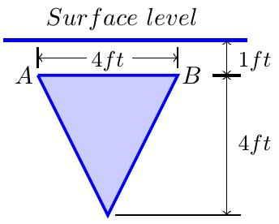

1. Find the fluid force against one face of the plate.
2. 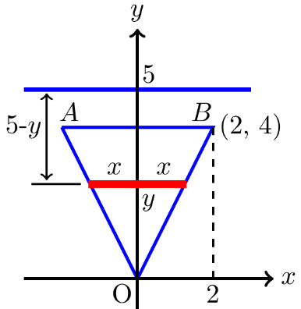What would be the fluid force on one side of the plate if the water were seawater instead of freshwater?

***Solution***

Line *OB*: 



Width: 



Depth: 

1. Freshwater Weight density: 

 











1. Seawater Weight density: 

 











***Exercise***

The isosceles triangular plate is submerged vertically 3 *feet* above the surface of a freshwater lake. What force does the water exert on one face of the plate now?

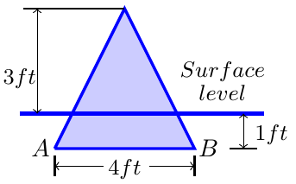

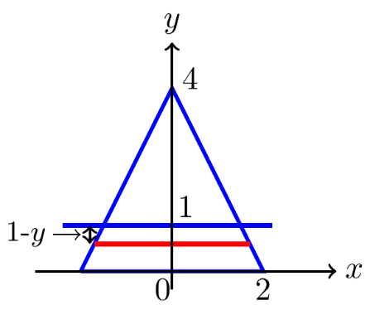***Solution***

Freshwater Weight density: 

Line: 



Width: 



Depth: 

 











***Exercise***

The cubical metal tank has parabolic gate held in place by bolts and designed to withstand a fluid force of 160 *lb*. without rupturing. The liquid you plan to store has a weight-density of .

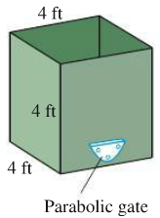 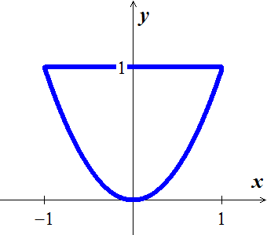

1. What is the fluid force on the gate when the liquid is 2 *feet* deep?
2. What is the maximum height to which the container can be filled without exceeding the gate’s design limitation?

***Solution***

From the graph:

 (*right side*)

Boundary: 

Width: 



Depth: 

***Given***: weight-density of 

1.  











1. 















The maximum height to which the container can be filled without exceeding the gate’s design limitation is 

***Exercise***

The end plates of the trough were designed to withstand a fluid force of 6,667 *lb*.

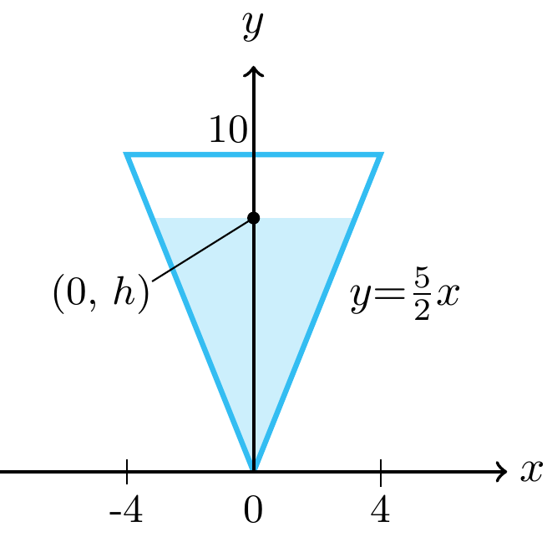 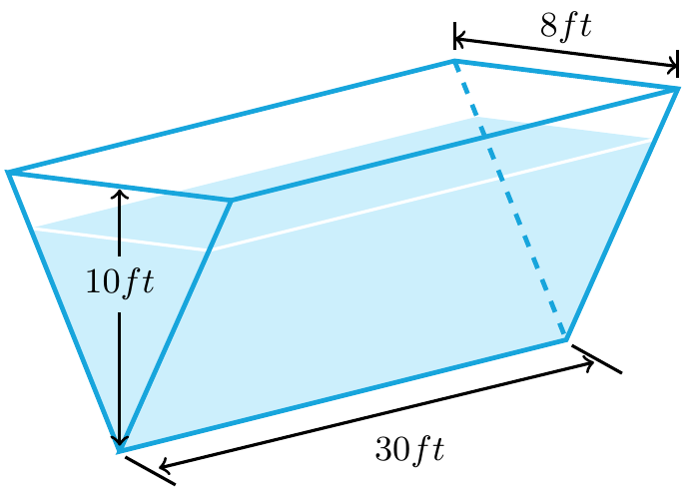

1. What is the value of *h*?
2. How many cubic feet of water can the tank hold without exceeding this limitation?

***Solution***



Boundary: 

Width: 



Depth: 

Freshwater Weight density: 

1.  















1. 













***Exercise***

A circular observation window on a marine science ship has a radius of 1 *foot*, and the center of the window is 8 *feet* below water level. What is the fluid force on the window?

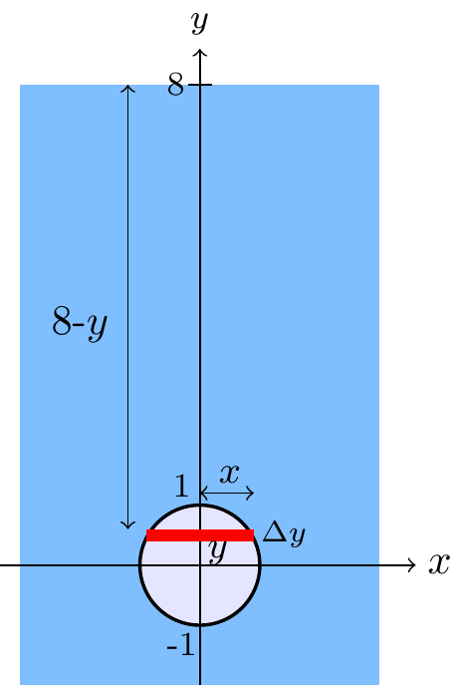***Solution***





Width: 



Depth: 

Boundary: 

Seawater Weight density: 













***Exercise***

Water pours into the tank at the rate of . The tank’s cross-sections are 4-*ft*-diameter semicircles. One end of the tank is movable, but moving it to increase the volume compresses a spring. The spring constant is . If the end of the tank moves 5 feet against the spring, the water will drain out of a safety hole in the bottom at the rate of . Will the movable end reach the hole before the tank overflows?

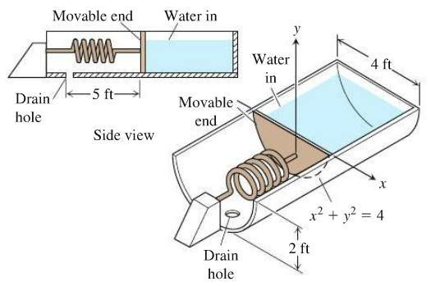

***Solution***

By Hooke’s law: 



Freshwater Weight density: 



*Width*: 



*Depth*: 

*Boundary*: 





















Since the tank is full when ; therefore, the tank will overflow and the spring will have compressed 